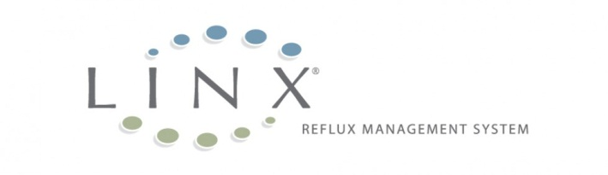

POST-OPERATIVE
PATIENT CARE

POST-OPERATIVE PATIENT CARE INSTRUCTIONS
Return to a normal diet as soon as tolerated; this is usually the day after surgery. The opening and closing of your Lower Esophageal Sphincter (LES), which takes place as you eat and drink, is important to help your body get used to the presence of the LINX System.

Following implantation of the LINX System, you may experience some discomfort or difficulty when swallowing. This is known as dysphagia. This is normal and expected. In most cases, dysphagia can be managed by taking smaller bites and chewing food more thoroughly. Dysphagia generally peaks 3 – 6 weeks after implant, is mild and resolves on its own.

If you experience difficulty swallowing, follow these steps:
- Drink a few sips of water before taking your first bite of food and between bites as necessary.
- Take small bites of foods that easily pass down your esophagus and into your stomach.
- Chew your food well before swallowing.
- Begin to identify foods that may make swallowing more difficult for you. Bread, pasta, rice, and meat may be more likely to cause problems.

Carry your LINX Implant Card as notification to care providers that you received a LINX System. If you lose this card, please contact your surgeon’s office to receive a replacement card.

In all cases, please follow the instructions of your physician. Consult your physician if you have questions about the information provided here.

WHEN TO CALL YOUR DOCTOR
After the procedure, your doctor will provide you with instructions about when to call. In general, you should contact your doctor if you have:
- Fever over 100.4 degrees or signs of infection
- Difficulty swallowing or inability to swallow
- Painful Swallowing
- Increased abdominal pain
- Nausea or vomiting
- Cough or difficulty breathing

You should also call your doctor if:
- You are told that you need to have an MRI procedure. You should not be exposed to an MRI environment. The MRI could cause injury to you and/or damage to the LINX System.
- You are told that you need other surgical procedure or endoscopic treatments of your esophagus. These may be contraindicated because of the presence of the LINX System.

FREQUENTLY ASKED QUESTIONS
Q. When can I start eating normally again?
Patients are encouraged to return to a normal diet as quickly as tolerated. This helps the body adapt to the LINX System.

Q. When can I return to normal physical activities?
Patients are generally able to return to non-strenuous activity within a couple of days.

Q. Can I go through airport security?
The LINX System should not affect airport security. All patients will be provided with an implant card to have available in the event an issue arises.

Q. Will the magnets wear out?
The LINX Reflux Management System uses permanent magnets that are designed not to wear out.

Torax ® Medical, Inc.
4188 Lexington Avenue North
Shoreview, Minnesota 55126, USA
www.toraxmedical.com
info@toraxmedical.com
Phone: 1 (651) 361-8900

